**Assignment3 Analysis Report**

* Xiaowei Wan

1. Plots:

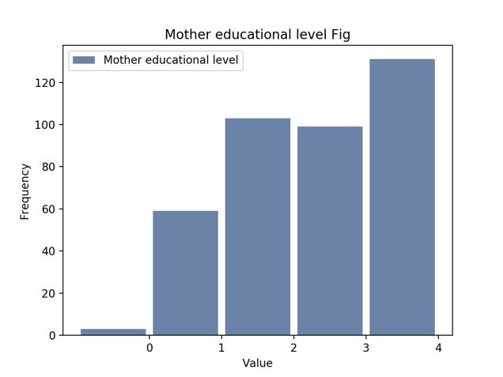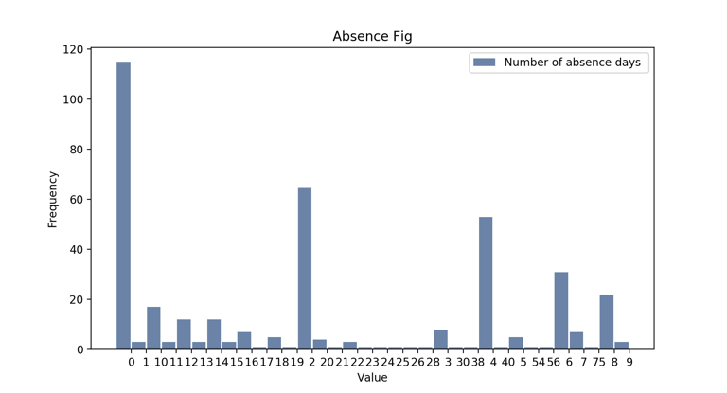

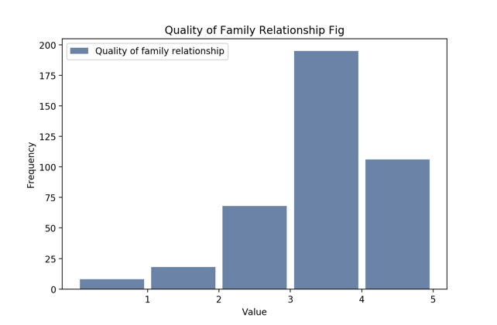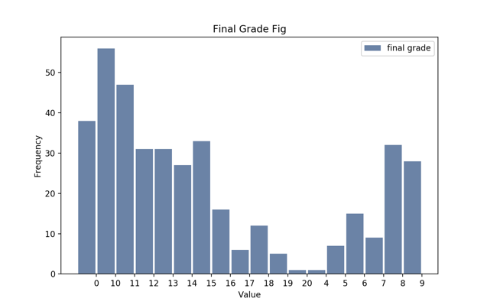

1. a. Mother educational level fig: Exponential Distribution

b. Absence fig: Pareto Distribution

c. Quality of Family Relationship fig: Poisson Distribution

d. Final Grade fig: Poisson Distribution